Ghibli Studio AI Review and Special Coupon

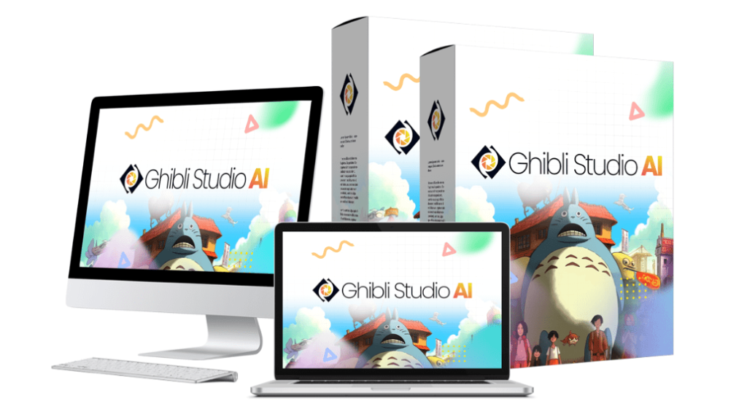

Have you ever been captivated by the enchanting visuals of Studio Ghibli films? The hand-drawn artistry, vibrant colors, and whimsical characters evoke a sense of wonder and nostalgia. But creating such stunning visuals yourself can feel like an impossible dream, often requiring years of artistic training and expensive software.

What if you could capture that Ghibli magic without needing to be an artist?

Enter [Ghibli Studio AI](https://indivestsage.com/ghibli-studio-ai-worlds-first-ghibli-style-ai-studio/), the world's first and only app that transforms any text prompt into breathtaking Ghibli-style visuals. Imagine turning your ideas into captivating images, storybook illustrations, unique logos, and much more, all with that distinctive Ghibli flair.

This review dives deep into Ghibli Studio AI, exploring its features, benefits, and potential. My goal is to provide you with an honest and comprehensive overview to help you decide if this innovative tool is the right fit for your creative needs.

Whether you're a content creator, marketer, aspiring author, or simply a Ghibli enthusiast, if you're in the USA or Canada (or anywhere else, really!), and want to easily generate amazing visuals, this review is for you.

Visit the [official websit](https://indivestsage.com/ghibli-studio-ai-worlds-first-ghibli-style-ai-studio/)e and grab **$5 Off** [**Discount Coupon**](https://indivestsage.com/ghibli-studio-ai-worlds-first-ghibli-style-ai-studio/) **= “GSA5OFF” or**  
**30% Off** [**Discount Coupon**](https://indivestsage.com/ghibli-studio-ai-worlds-first-ghibli-style-ai-studio/) **= “GSA30OFF”**

**What is** [**Ghibli Studio AI**](https://indivestsage.com/ghibli-studio-ai-worlds-first-ghibli-style-ai-studio/)**?**

At its core, Ghibli Studio AI is an innovative software that uses the power of artificial intelligence to generate visuals in the distinctive style of Studio Ghibli. This means you can create images that capture the charm, beauty, and emotional depth of beloved Ghibli films, all through the magic of AI.

Read also: [Ghibli Studio AI Review: Ghibli AI Turns Your Prompts into Breathtaking Art](https://indivestsage.com/ghibli-studio-ai-review/)

Ghibli Studio AI goes far beyond simply creating images. It's a versatile tool that allows you to generate a wide array of visual content, including:

[Explore Ghibli Studio AI Features](https://indivestsage.com/ghibli-studio-ai-worlds-first-ghibli-style-ai-studio/)

* Ghibli-Style Images: Stunning standalone images perfect for personal projects or sharing online.
* Kids' Storybooks: Create captivating visuals to accompany children's stories.
* Logo Sets: Design unique and memorable logos with a Ghibli-inspired aesthetic.
* Printable Coloring Books: Offer engaging and creative activities with custom-generated coloring pages.
* YouTube Thumbnails: Craft eye-catching thumbnails to boost your video views.
* Characters for Merch: Design original characters for merchandise like t-shirts, mugs, and more.
* Scroll-stopping Social Posts: Create attention-grabbing visuals for your social media feeds.
* And Literally Any Visual Asset You Can Think Of…: The possibilities are limitless, encouraging users to explore their creativity.

All of these visuals are generated in HD quality and are fully customizable, giving you control over the final result.

What truly sets Ghibli Studio AI apart is that it's the world’s first and only app of its kind. And to top it off, it comes with Unlimited Lifetime Access. This means you get all of these amazing features for a one-time cost.

[**See How Ghibli AI Can Help You**](https://indivestsage.com/ghibli-studio-ai-worlds-first-ghibli-style-ai-studio/)

**Key Features and Benefits**

Ghibli Studio AI isn't just a one-trick pony; it's a versatile platform packed with features that cater to a wide range of creative needs. Let's explore each of its core functionalities and the incredible benefits they offer:

**1. Ghibli-Style Image Generator**

[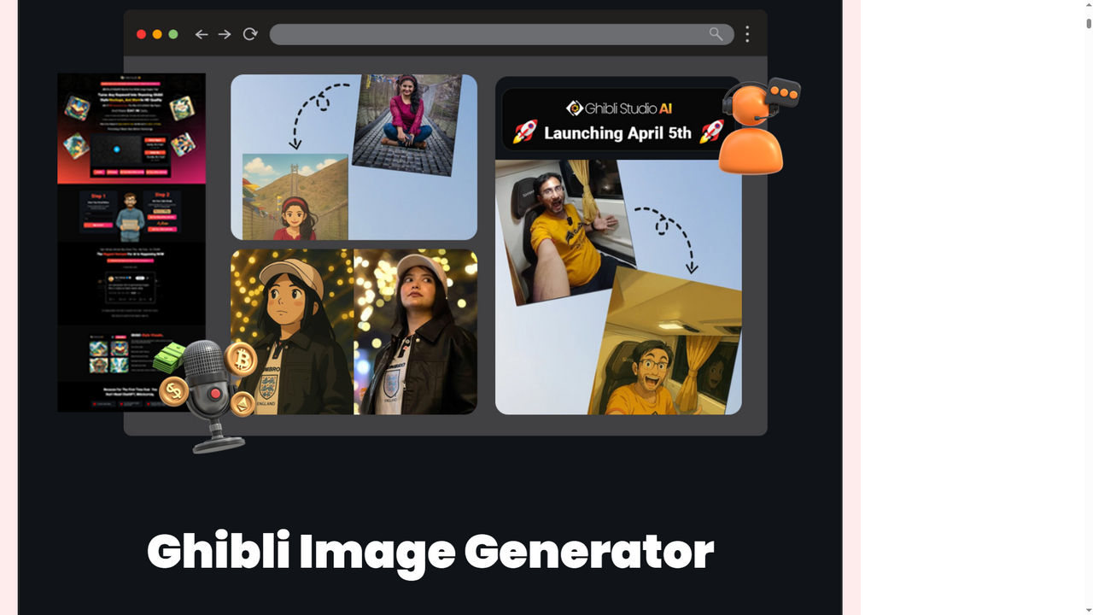](https://www.deviantart.com/stash/0151kcdzdrlw)

Ghibli Studio AI excels at generating standalone images that perfectly capture the Ghibli aesthetic. Expect to see the soft, painterly textures, the vibrant color palettes, and the expressive character designs that define this iconic style. The output is high-definition, ensuring crisp and detailed visuals.

These images are perfect for:

* Personal projects: Creating unique wallpapers, social media avatars, or digital artwork.
* Blog illustrations: Adding eye-catching visuals to your blog posts.
* Storyboarding: Visualizing scenes for animations or comics.
* Concept art: Developing characters and environments for games or other creative projects.

[Create Ghibli-Style Images Now](https://indivestsage.com/ghibli-studio-ai-worlds-first-ghibli-style-ai-studio/)

✅ Benefit: Stand out from generic AI art with a hand-crafted aesthetic.

**2. Kids’ Storybook Creator**

[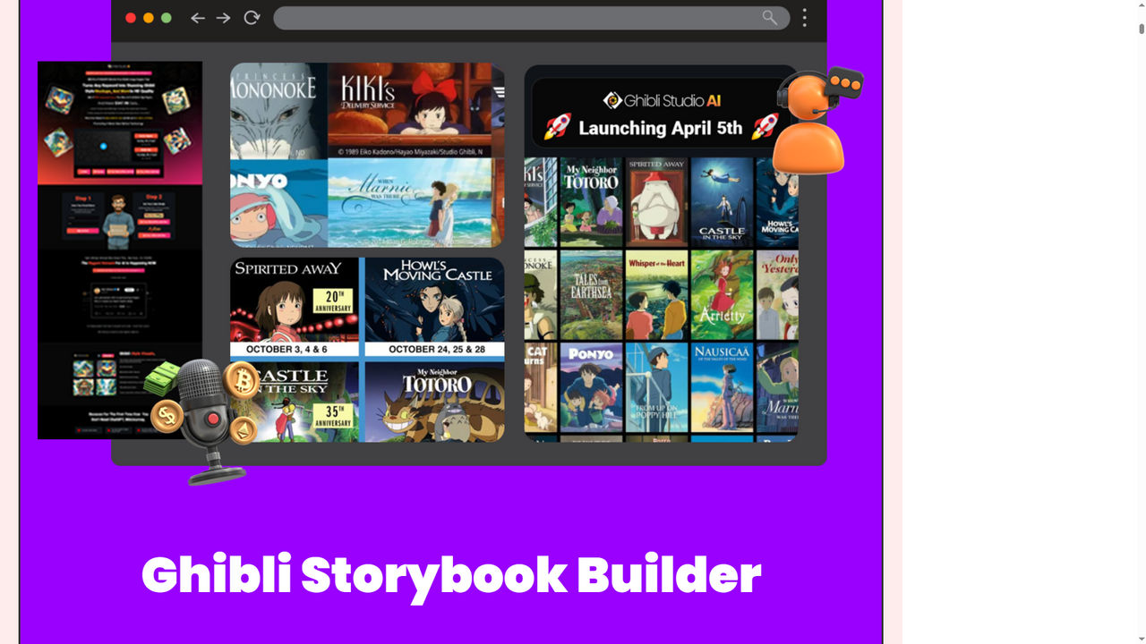](https://www.deviantart.com/stash/01my92e0xjrz)

This feature simplifies the process of creating visuals for children's stories. Imagine being able to generate charming characters, whimsical backgrounds, and engaging scenes that bring your narratives to life.

✅ Benefit: This can be a game-changer for aspiring children's book authors, educators, or parents who want to create personalized storybooks. It removes the barrier of needing advanced illustration skills.

[**Create Your Storybook with AI**](https://indivestsage.com/ghibli-studio-ai-worlds-first-ghibli-style-ai-studio/)

**3. Ghibli-Style Logo Sets**

[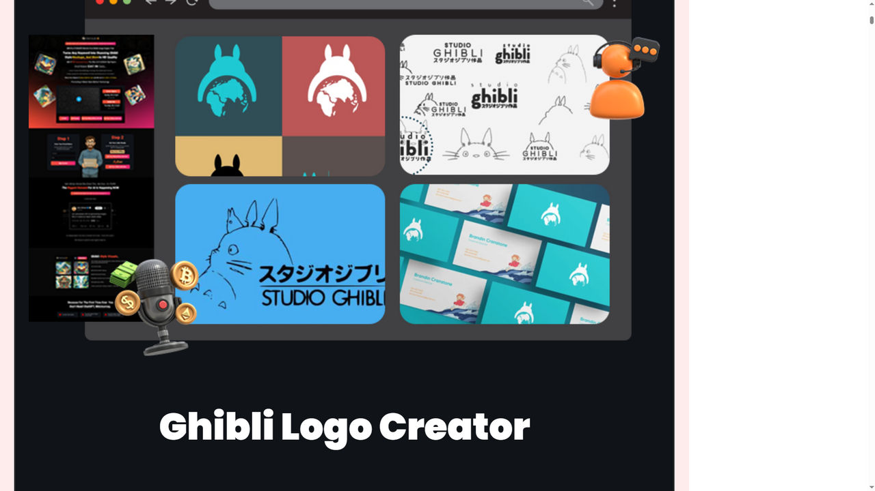](https://www.deviantart.com/stash/0y7esc7hfeq)

Ghibli Studio AI can help you design unique and memorable logos with a distinct Ghibli flavor. This allows businesses and brands to stand out with a creative and artistic identity.

✅ Benefit: Simplifies the logo design process and offers a unique alternative to conventional logo styles. No graphic design skills are required — just type your brand name.

[**Design Your Ghibli-Inspired Logo**](https://indivestsage.com/ghibli-studio-ai-worlds-first-ghibli-style-ai-studio/)

**4. Printable Coloring Books**

[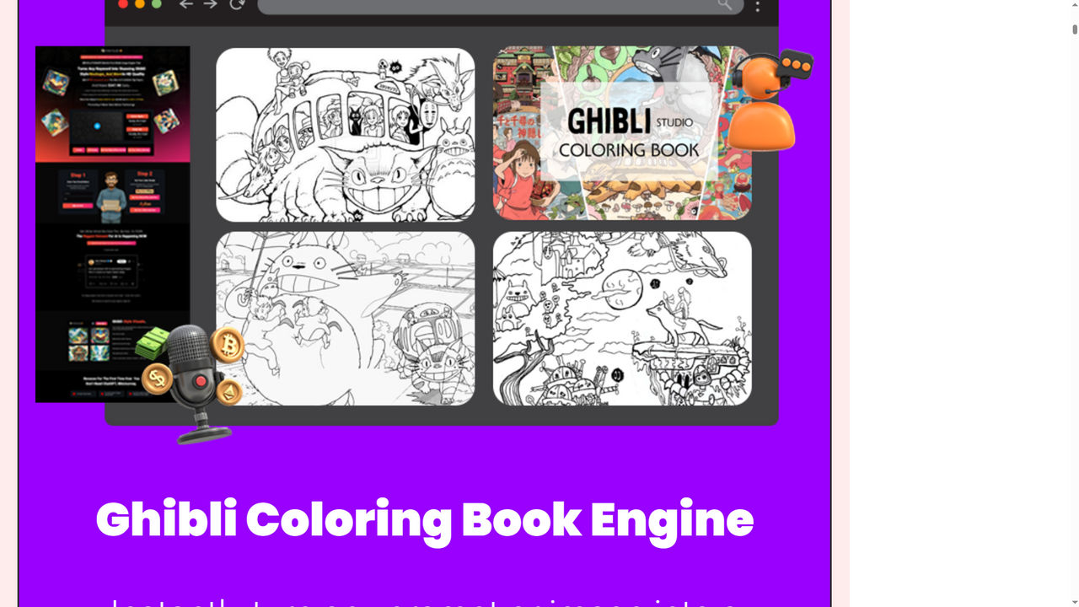](https://www.deviantart.com/stash/06sjjj5v458)

This is a particularly unique feature. Ghibli Studio AI can generate line art based on prompts, which can then be used to create printable coloring pages.

✅ Appeal: This opens up opportunities for creating personalized coloring books for kids or adults, offering a relaxing and creative activity.

[**Generate Coloring Book Pages**](https://indivestsage.com/ghibli-studio-ai-worlds-first-ghibli-style-ai-studio/)

**5. YouTube Thumbnails & Video Visuals**

[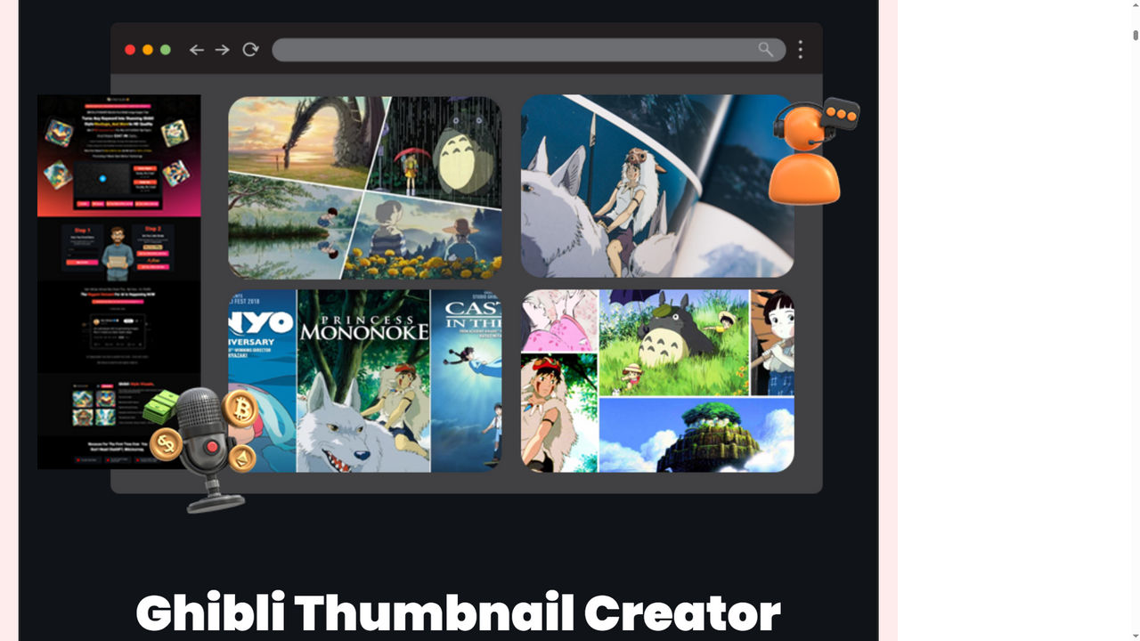](https://www.deviantart.com/stash/02kuzjn1tte)

In the crowded world of YouTube, eye-catching thumbnails are essential. Ghibli Studio AI helps you create visually appealing thumbnails that grab viewers' attention and entice them to click on your videos.

✅ Benefit: Enhance video content by providing unique and attractive visuals that can increase click-through rates.

[**Enhance Your Thumbnails Now**](https://indivestsage.com/ghibli-studio-ai-worlds-first-ghibli-style-ai-studio/)

**6. Characters for Merch**

[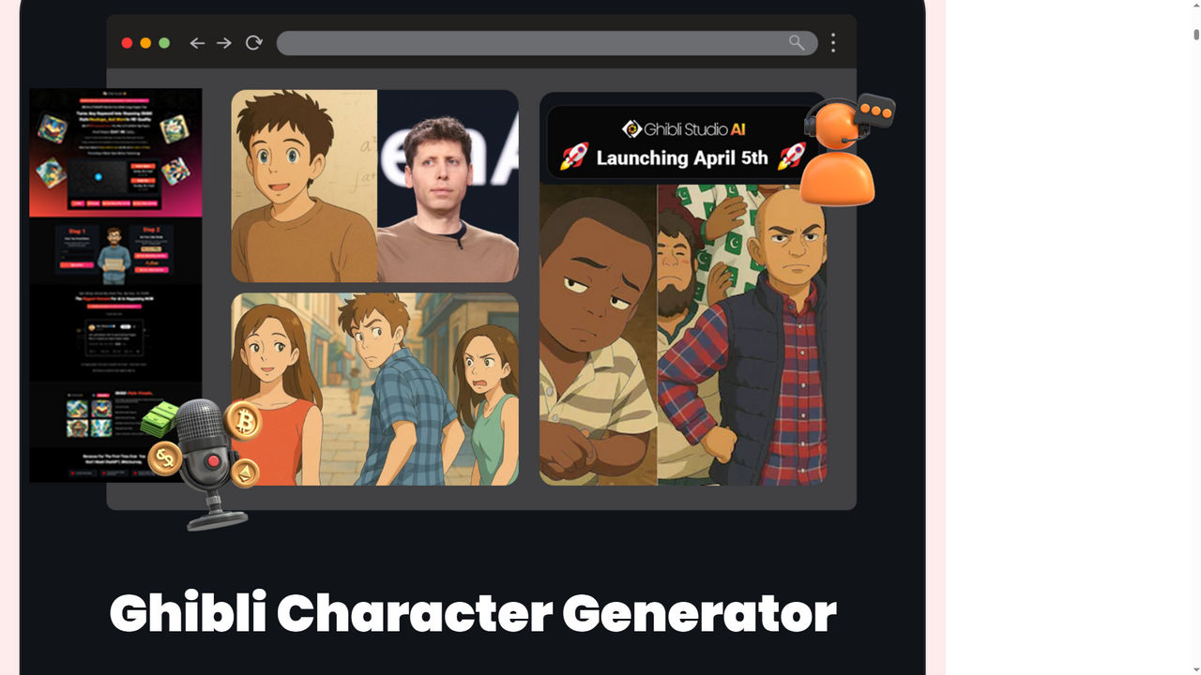](https://www.deviantart.com/stash/0irdhugfdg6)

Design original, stylized characters in the Ghibli style for merchandise such as t-shirts, mugs, stickers, and more.

✅ Potential: This feature opens up possibilities for artists and entrepreneurs to create and sell unique merchandise featuring their own Ghibli-inspired characters. Unlimited ideas for passive income products.

[Design Characters for Merchandise](https://indivestsage.com/ghibli-studio-ai-worlds-first-ghibli-style-ai-studio/)

**7. Scroll-Stopping Social Media Posts**

Create visually arresting images for social media that stand out from the endless scroll.

✅ Benefit: Helps users create engaging content that captures attention and increases social media engagement. Boost engagement and reach without hiring designers.

[**Create Engaging Social Posts**](https://indivestsage.com/ghibli-studio-ai-worlds-first-ghibli-style-ai-studio/)

**8. And Literally Any Visual Asset You Can Think Of…**

Ghibli Studio AI is designed to be versatile and adaptable. It encourages users to experiment and push the boundaries of what's possible.

✅ Benefit: Unleash your creativity and explore new income streams with ease.

[**Unleash Your Creativity with Ghibli AI**](https://indivestsage.com/ghibli-studio-ai-worlds-first-ghibli-style-ai-studio/)

**Overall Benefits:**

Beyond the specific features, Ghibli Studio AI offers several overarching benefits:

* Saves Time and Effort: Generating high-quality visuals can be time-consuming and require significant effort. Ghibli Studio AI streamlines the process, allowing users to create stunning images in a fraction of the time.
* Accessibility for Those Without Design Experience: One of the most significant advantages is its user-friendliness. You don't need to be a skilled artist or graphic designer to create impressive visuals. Ghibli Studio AI makes Ghibli-style art accessible to everyone.
* Potential for Commercial Use: The generated visuals can be used for various commercial purposes, such as creating marketing materials, designing merchandise, or illustrating books. This opens up opportunities for users to monetize their creativity.
* Fully Accessible: Works on any device, directly in your browser.
* One-Time Purchase: No monthly fees or subscriptions.

[**Get Started with Ghibli Studio AI**](https://indivestsage.com/ghibli-studio-ai-worlds-first-ghibli-style-ai-studio/)

**User-Friendliness: AI Magic with Zero Learning Curve**

Ghibli Studio AI is designed to be exceptionally user-friendly:

* Ease of Use: Emphasizes "No Experience - No API - No Monthly Fees".
* Simple Visual Generation: Users generate visuals using simple text prompts.
* Customizable Output: The generated output is customizable, allowing users to fine-tune results. Choose animation duration and frame rate, add positive and negative prompts to fine-tune styles, instantly preview your creation before downloading, and upload your own images to be animated Ghibli-style.

[Experience the Ease of Use](https://indivestsage.com/ghibli-studio-ai-worlds-first-ghibli-style-ai-studio/)

**Who can benefit**

While Ghibli Studio AI can be enjoyed by anyone with an appreciation for art and creativity, it's particularly well-suited for those in tier-1 countries like the USA and Canada. Here's a breakdown of who would benefit most from this powerful tool:

* Content Creators: Ideal for bloggers, YouTubers, and social media influencers looking to enhance their content with unique and engaging visuals. Create viral YouTube thumbnails, Reels, Shorts, and social media posts that stop the scroll.
* Marketers: A valuable asset for creating eye-catching marketing materials, advertisements, and branding assets that stand out from the competition. Design high-converting visuals for ads, promos, and brand campaigns with ease.
* Authors: Perfect for writers who want to visualize characters, scenes, and settings for their stories, or even create illustrations for their books. Build captivating kids’ storybooks or visual content for lessons, homeschooling, and more.
* Graphic Designers: A great tool for graphic designers seeking to add a distinctive Ghibli touch to their projects or explore new creative avenues. Add a new style to your toolkit and boost productivity with AI-generated concepts.
* Hobbyists: Anyone with a passion for art and a desire to create their own Ghibli-inspired masterpieces, regardless of their skill level. Have fun turning your ideas into art, GIFs, and mini animations with no skills needed.
* Ghibli Enthusiasts: Ultimately, anyone who loves the art style of Studio Ghibli will find Ghibli Studio AI to be a fun and rewarding tool for bringing their creative visions to life.

No matter your niche or goals, Ghibli Studio AI empowers anyone to create visuals that feel magical, hand-crafted, and totally one-of-a-kind.

[See How Ghibli AI Can Help You](https://indivestsage.com/ghibli-studio-ai-worlds-first-ghibli-style-ai-studio/)

**Guarantee and Support**

Ghibli Studio AI comes with a 30-day money-back guarantee. This allows you to try the software risk-free and ensures that you can get a full refund if it doesn't meet your expectations.

Ghibli Studio AI comes from a team that understands the importance of user experience. If you run into any issues, need guidance, or have questions, help is available through:

* Email support
* Help desk or support portal (usually provided post-purchase)
* Frequently Asked Questions (FAQs) section for quick troubleshooting

While support specifics may vary depending on where you purchase (e.g., JVZoo, WarriorPlus), rest assured that your satisfaction is a priority.

**Pros and Cons of Ghibli Studio AI**

Like any software, Ghibli Studio AI has its strengths and weaknesses. Here's a balanced overview to help you make an informed decision:

**Pros:**

* Easy to Use: Ghibli Studio AI is designed for simplicity, requiring "No Experience - No API" and offering an intuitive user interface.
* Versatile Output Options: The software generates a wide range of visuals, including images, storybooks, logos, and more.
* Time-Saving: It significantly reduces the time and effort required to create high-quality visuals.
* Cost-Effective: The "No Monthly Fees" and "Unlimited Lifetime Access" model offers excellent value.
* Unique Ghibli-Style Focus: It's the "World’s first and only app" that specializes in generating visuals in the distinctive Ghibli style.
* Commercial Use Potential: The generated visuals can be used for various commercial purposes.
* Browser-Based: Access it from any device, anytime.

**Cons:**

* AI Dependency: Output quality can vary based on prompts; creative direction is still algorithm-driven.
* Internet Connection Required: Since it’s browser-based, you’ll need to be online to use it.

Overall, the pros far outweigh the cons — especially for non-designers, solo entrepreneurs, or anyone looking to create magical visuals with minimal effort.

**Conclusion: Should You Get Ghibli Studio AI?**

Ghibli Studio AI is a groundbreaking tool that democratizes the creation of Ghibli-style visuals. It offers a unique combination of ease of use, versatility, and affordability.

With its ability to generate a wide array of visual content – from stunning images and engaging storybooks to eye-catching logos and social media posts – it empowers users to unleash their creativity and bring their Ghibli-inspired visions to life.

The "No Experience - No API - No Monthly Fees" approach makes it accessible to everyone, while the "Unlimited Lifetime Access" provides exceptional long-term value.

If you've ever dreamed of creating your own art in the style of Studio Ghibli, or if you're a content creator, marketer, or designer looking for a unique and efficient way to generate visuals, I wholeheartedly recommend giving Ghibli Studio AI a try.

**Why We Recommend It:**

* Zero learning curve — perfect for beginners and busy pros alike
* All-in-one tool for creating scroll-stopping, sellable content
* Lifetime access — no monthly fees, no hidden costs
* Commercial rights — monetize your creations freely
* Perfect for creators in the USA & Canada looking to stand out

**Ready to Bring Your Visual Ideas to Life?**

👉 [Click below to grab Ghibli Studio AI now](https://indivestsage.com/ghibli-studio-ai-worlds-first-ghibli-style-ai-studio/) and start creating stunning Ghibli-style visuals in just minutes.

[Insert Your Affiliate Link Here]

⚡ Hurry — Limited-Time Deal!

This offer won’t be around forever, and once it’s gone, you might miss out on exclusive bonuses or lifetime pricing. Don’t wait — tap into the AI design revolution today.

[**Special Offer!**](https://indivestsage.com/ghibli-studio-ai-worlds-first-ghibli-style-ai-studio/)

[**$5 Off Discount Coupon = “GSA5OFF”**  
**30% Off Discount Coupon = “GSA30OFF”**]

Don't miss out on this opportunity to own the world's first and only Ghibli-style AI studio. Embrace the magic and start creating today!

Full disclosure: As an affiliate, I may earn a commission if you purchase Ghibli Studio AI through my link. Rest assured, this review is based on my honest assessment of the product.